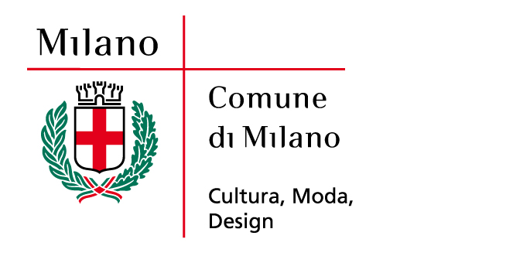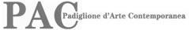

EXHIBITION DETAILS

TITLE ELAD LASSRY

EXHIBITION PROMOTED City of Milan | Culture, Fashion, Design | PAC Padiglione
AND PRODUCED BY d’Arte Contemporanea

CURATOR Alessandro Rabottini

LOCATION PAC Padiglione d’Arte Contemporanea | via Palestro 14 | Milan Italy

ON SHOW a large selection of wall works, four films, new sculptures and an installation that combines photography, sculpture and architecture, made specifically for the PAC space, inaugurate the first monographic exhibition that an Italian museum has devoted to the work of Elad Lassry (b. 1977, Tel Aviv), an internationally renowned Israeli artist whose work is characterized by a reflection on the ubiquity of the image in contemporary society and the possibility of redefining known visual codes and interpretative habits

EXHIBITION DATES From 6 July until 16 September 2012

HOURS Monday, 2.30 p.m._7.30 p.m | Tuesday-Sunday, 9.30 a.m._7.30 p.m. | Thursday, until 10.30 p.m. | Last entry 1 hour before closing

ADMISSION FREE

PRESS CONFERENCE Thursday, 5 July | h. 11.30 a.m.
PAC Padiglione d’Arte Contemporanea | via Palestro 14 | Milan
Italy

INAUGURATION Thursday, 5 July | h. 6.00 p.m.

INFORMATION tel. +39 02 88446359
www.comune.milano.it/pac

PRESS OFFICES Exhibition Press Office
Studio Pesci, Sara Zolla | cell. +39 335 1990469 | tel. +39 051
269267 | sara.zolla@studiopesci.it | info@studiopesci.it
Press Office – City of Milan
Elena Conenna | tel. + 39 02 88453313
Elenamaria.Conenna@comune.milano.it

PAC SPONSOR TOD’S Group

SPONSOR OF Gruppo COOP Lombardia
EDUCATIONAL ACTIVITIES

